Ocars Website Testing
Testing : Majd AL-Manaseer
Date :18/nov/2025
User Testing :

Back End testing :

- When testing employee account , and click on any tab like report , an alert message shown in the top of the website. A status code 403(Forbidden), the request path is: https://o-carz.com/api/reports/general? , also I added a screenshots of this issue.

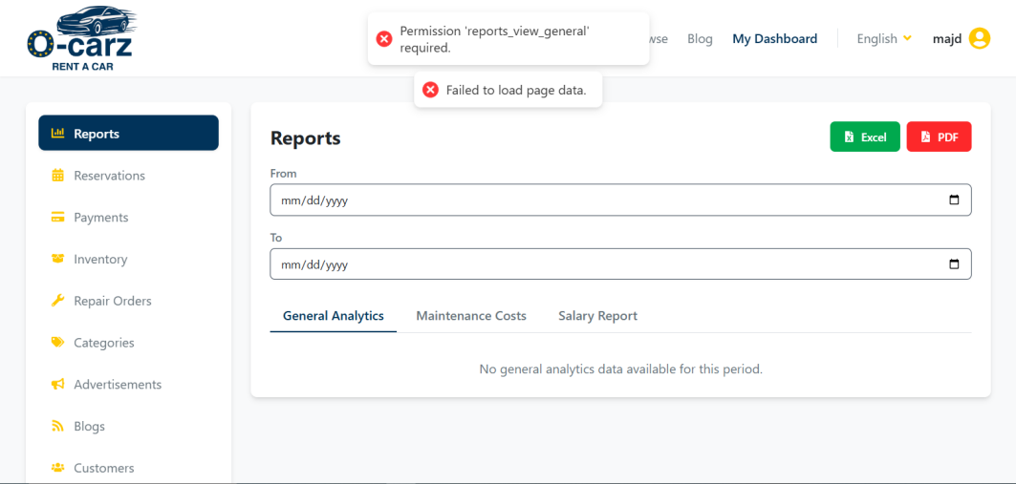

- When testing the login functionality and login with employee account, an alert message shown in the top of the website. A status code 403(Forbidden), the request path is: https://o-carz.com/api/reports/general? , also I added a screenshots of this issue.

